1.Install Apache
Create custom HTML PAGE, Print your name on it.
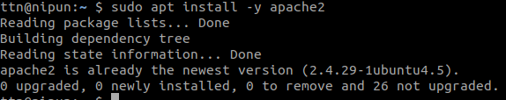

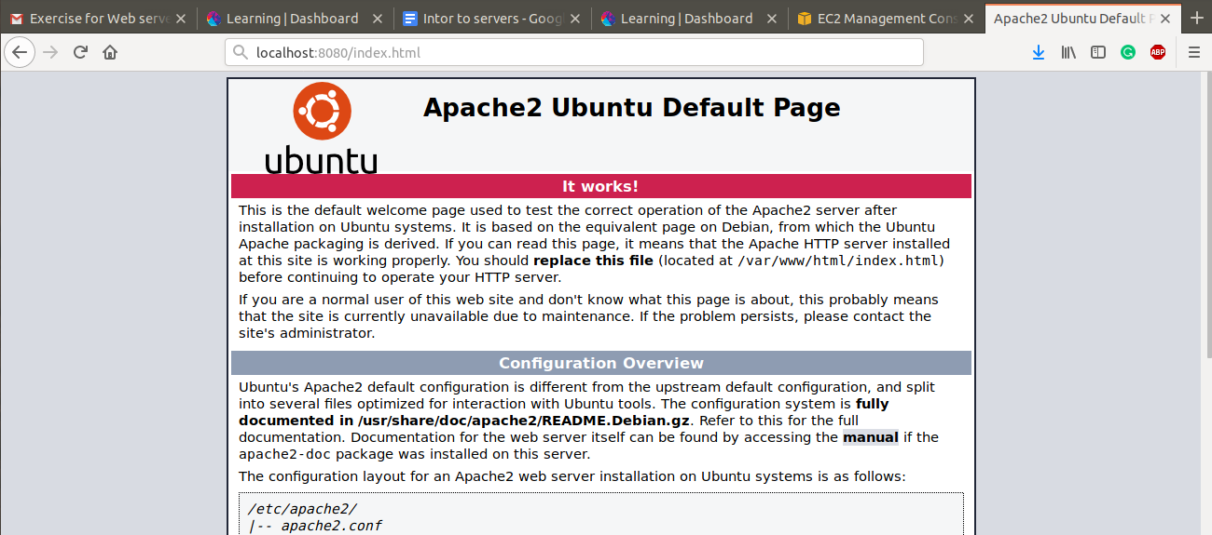

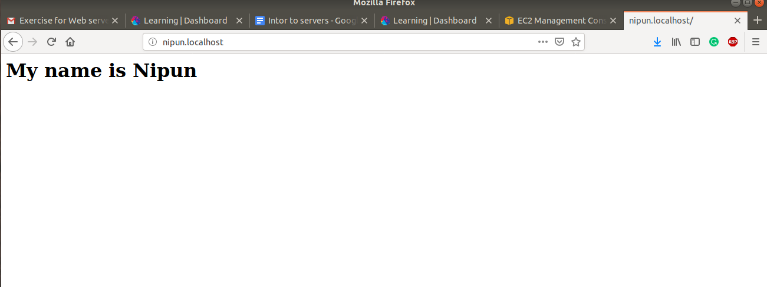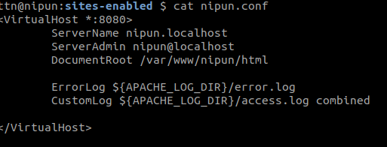

2.Install NGINX Server.

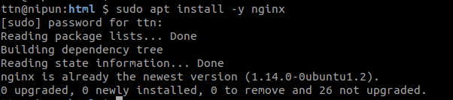

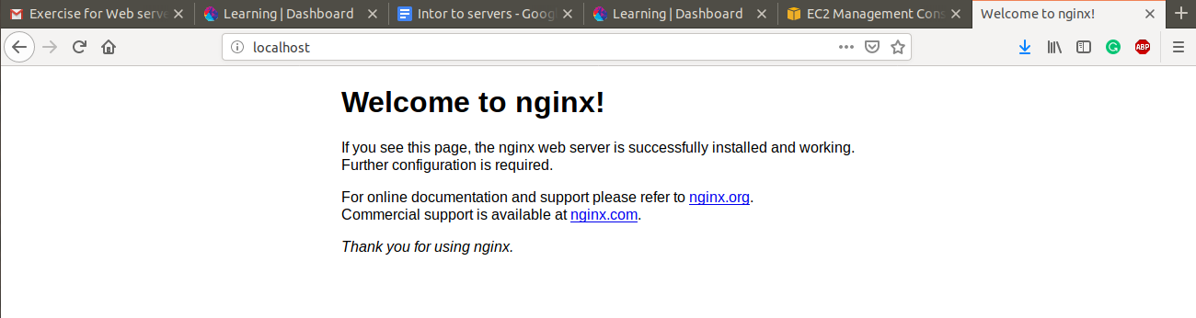

3.PUT vs POST

PUT | POST
RFC-2616 clearly mention that PUT method requests for the enclosed entity be stored under the supplied Request-URI. If the Request-URI refers to an already existing resource – an update operation will happen, otherwise create operation should happen if Request-URI is a valid resource URI (assuming client is allowed to determine resource identifier).  PUT /questions/{question-id} | The POST method is used to request that the origin server accept the entity enclosed in the request as a new subordinate of the resource identified by the Request-URI in the Request-Line. It essentially means that POST request-URI should be of a collection URI.  POST /questions
PUT method is idempotent. So if you send retry a request multiple times, that should be equivalent to single request modification. | POST is NOT idempotent. So if you retry the request N times, you will end up having N resources with N different URIs created on server.
Use PUT when you want to modify a singular resource which is already a part of resources collection. PUT replaces the resource in its entirety. Use PATCH if request updates part of the resource. | Use POST when you want to add a child resource under resources collection.
PUT is idempotent, so you can cache the response. | Responses to this method are not cacheable, unless the response includes appropriate Cache-Control or Expires header fields. However, the 303 (See Other) response can be used to direct the user agent to retrieve a cacheable resource.
Generally, in practice, always use PUT for UPDATE operations. | Always use POST for CREATE operations.

4.How Does SSL work?
1.A browser or server attempts to connect to a website (i.e. a web server) secured with SSL. The browser/server requests that the web server identify itself.
2.The web server sends the browser/server a copy of its SSL certificate.
3.The browser/server checks to see whether or not it trusts the SSL certificate. If so, it sends a message to the web server.
4.The web server sends back a digitally signed acknowledgement to start an SSL encrypted session.
5.Encrypted data is shared between the browser/server and the web server.
5.List out five difference in Apache and Nginx

Apache | Nginx
Apache follows multi-threaded approach to process client requests. | Nginx uses an event-driven approach to serve client requests.
It cannot process multiple requests concurrently with heavy web traffic. | It can process multiple client requests concurrently and efficiently with limited hardware resources.
It handles dynamic content within the web server itself. | It cannot process dynamic content natively.
Apache is designed to be a web server. | Nginx is both a web server and a proxy server.
A single thread can only process one connection. | A single thread can handle multiple connections.

6.What is Virtual HOST?

Virtual hosts are basically the feature of being able to host multiple websites on a single server. This is extremely useful given that you own multiple sites and don’t want to go through the lengthy (and expensive) process of setting up a new web server for each site.

7.What is Document ROOT?
The document root is a directory (a folder) that is stored on your host's servers and that is designated for holding web pages.

8.List out five difference in REST and SOAP web service?

REST | SOAP
Function driven: transfer structured information | Data driven: access a resource for data
Uses XML only | Plain text, HTML, XML, JSON
Support SSL, and WS-Security | Support HTTPS and SSL
Require more resources and bandwidth | Require fewer resources and lighter
Can’t be cached | Can be cached

9.Explain all below mentioned HTTP status code in your words with examples?
HTTP STATUS CODE: 200, 300, 301, 302, 304, 307, 400, 401, 403, 404, 500, 503, 550

200 : Standard response for HTTP successful requests.

300 : The requested address refers to more than one file. Depending on how the server is configured, you get an error or a choice of which page you want.

301 : If the server is set up properly it will automatically redirect the reader to the new location of the file.

302 : Page has been moved temporarily, and the new URL is available. You should be sent there by the server.

304 : If the request header includes an 'if modified since' parameter, this code will be returned if the file has not changed since that date. Search engine robots may generate a lot of these.

307 : redirect status response code indicates that the resource requested has been temporarily moved to the URL given by the Location headers.

400 : There is a syntax error in the request, and it is denied.
401 : The request header did not contain the necessary authentication codes, and the client is denied access.

403 : The client is not allowed to see a certain file. This is also returned at times when the server doesn't want any more visitors.

404 : The requested file was not found on the server. Possibly because it was deleted, or never existed before. Often caused by misspellings of URLs.

500 : Nasty response that is usually caused by a problem in your Perl code when a CGI program is run.

503 : The service or file that is being requested is not currently available.

550 : The server is stating the account you have currently logged in as does not have permission to perform the action you are attempting. You may be trying to upload to the wrong directory or trying to delete a file.

